# **CTF Topic: HTTP IN Details**

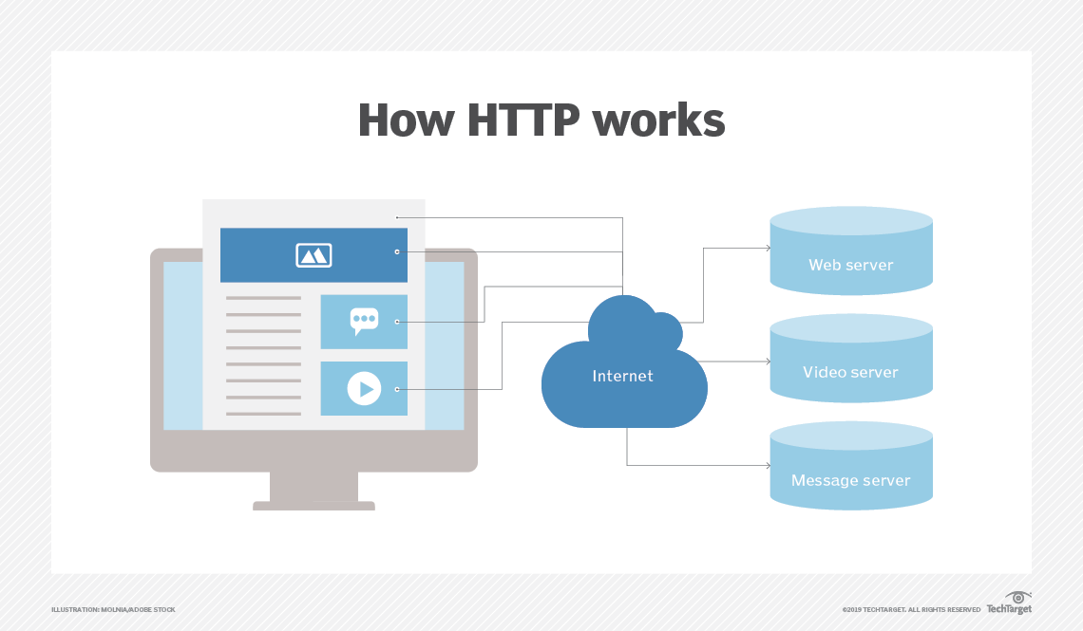

# **Introduction**

HTTP, or Hypertext Transfer Protocol, is a protocol that defines how messages are formatted and transmitted over the web. It enables communication between clients (such as browsers) and servers, facilitating the transfer of various types of data including text, images, videos, and more.

# **Why HTTP is needed**

HTTP is essential for accessing and interacting with web resources. It enables users to retrieve web pages, submit form data, download files, and engage with web applications. Without HTTP, the seamless browsing experience we're accustomed to on the web would not be possible.

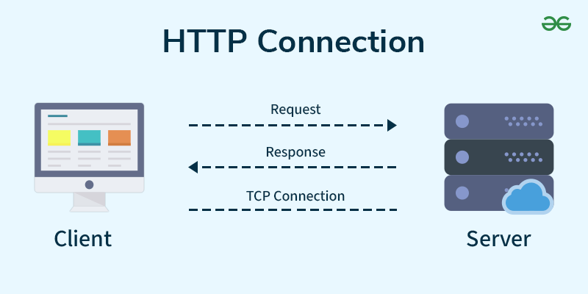

# **How HTTP is Implemented**

HTTP operates through a series of request-response cycles. Here's an overview of the process:

* **Client Request**: A client sends an HTTP request to a server. This request includes a method (such as GET, POST, PUT, DELETE) indicating the action to be performed and a URL specifying the resource.
* **Server Processing**: Upon receiving the request, the server processes it based on the specified method and URL. It may fetch data from databases, generate dynamic content, or retrieve static files.
* **HTTP Response**: The server sends back an HTTP response to the client. This response includes a status code indicating the outcome of the request (e.g., success, redirection, client error, server error) and the requested content, if applicable.

### **HTTP Status Codes**

HTTP status codes are three-digit numbers included in responses to convey the result of the request. Here are some common categories:

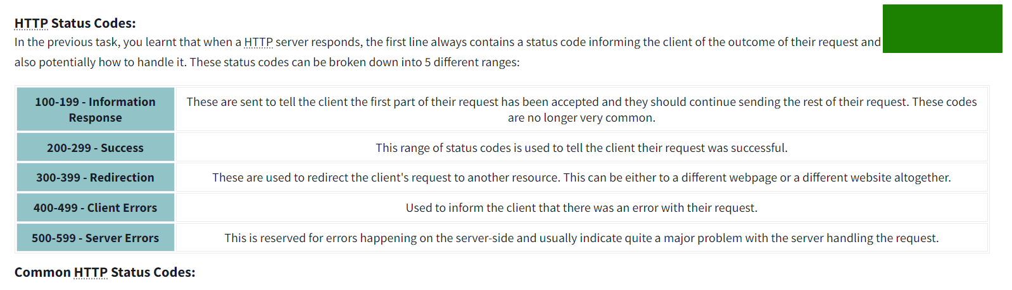

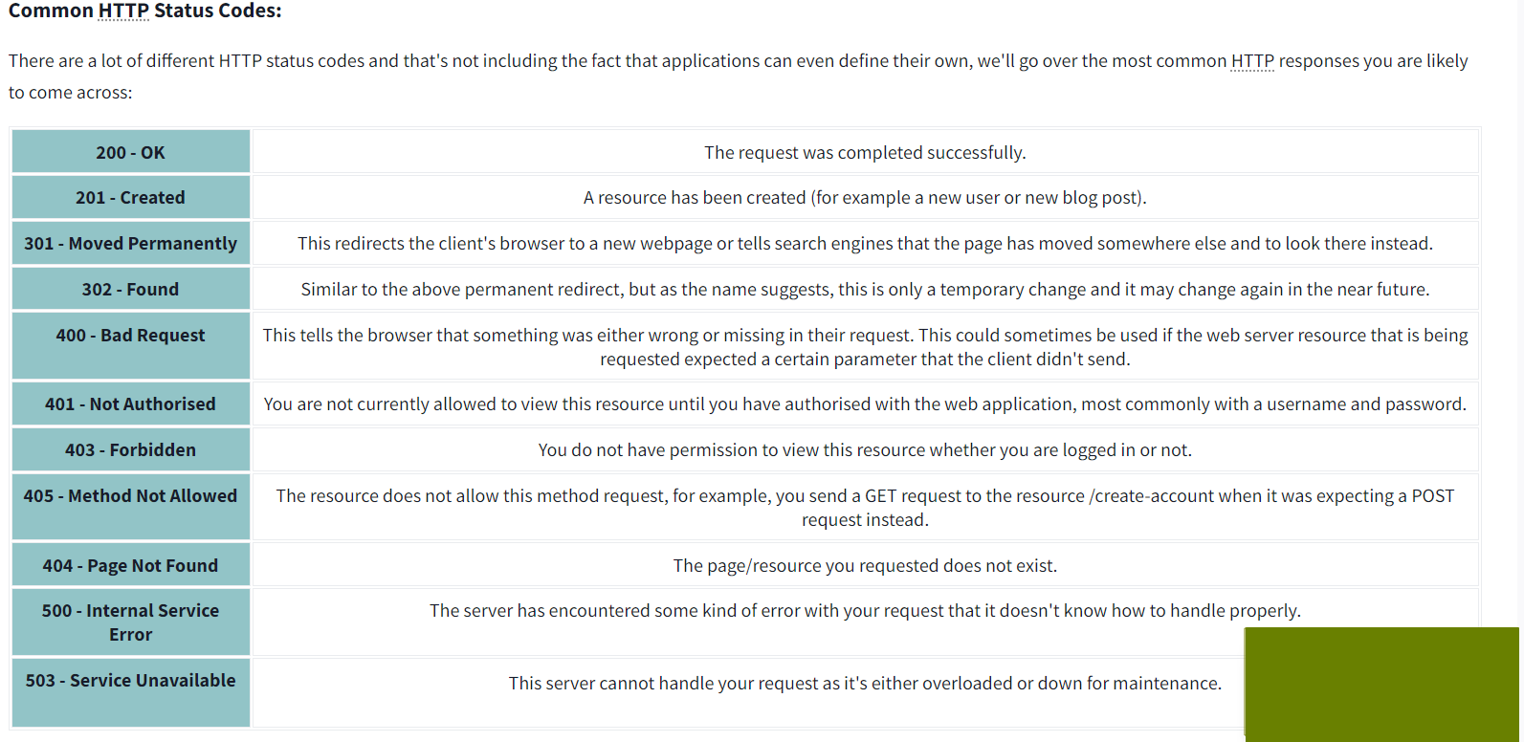

* 1xx Informational: Indicates the server is processing the request.
* 2xx Success: Indicates the request was successful (e.g., 200 OK for successful GET requests).
* 3xx Redirection: Indicates further action is needed to complete the request (e.g., 301 Moved Permanently, 302 Found for redirections).
* 4xx Client Error: Indicates a problem with the client's request (e.g., 404 Not Found for missing resources, 403 Forbidden for unauthorised access).
* 5xx Server Error: Indicates an issue on the server side (e.g., 500 Internal Server Error for generic server errors, 503 Service Unavailable for temporary unavailability).

# **Let’s start the Challenge**

# **Question**

Flag 1: Who is the inventor of the World Wide Web?

* Tim Berners-Lee

Flag 2: What protocol is used for secure communication over a computer network?

* Flag 1: HTTPS

Flag 3: Where does the client send the HTTP request to?

* Server

Flag 4: When was the first version of HTTP introduced?

* 1991

Flag 5: Why is a 404 status code returned?

* Missing